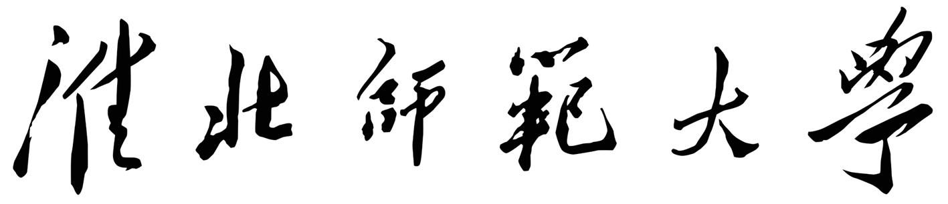

外国留学生来华学习申请表
APPLICATION FORM FOR INTERNATIONAL STUDENTS OF HUAIBEI NORMAL UNIVERSITY

注：请用以英文或中文印刷体填写,推荐机打。
Note: This form is to be completed in block letter in Chinese or English, printing recommended.

姓名  Passport Name | 中文In Chinese |  |  |  |  |  |  |  |  |  |  |  | 照片  Photo  Passport size
姓名  Passport Name | 英文 In English
国 籍  Nationality |  |  |  |  | 护照号码  Passport NO.
性别  Gender | □男/M  □女/F |  |  |  | 婚姻状况  Marital Status
出生日期  Date of Birth | 年 月 日  Y M D |  |  |  |  | 出生地点  Place of Birth
母语  Native Language |  |  |  |  |  | 宗教  Religion
最高学历  Highest Academic  Degree Obtained | □高中/Senior High School Graduate;  □本科/Undergraduate □大学在读/College Student □硕士/Master  □博士/Doctor □其他/Others
当前联系地址
Present Address
电话/Tel |  |  |  | 传真/Fax |  |  |  |  |  |  | E-mail
本国地址
Address in Homeland
家庭电话  Family Tel |  |  |  |  |  |  | 手机  Mobile Phone
教育背景Education Background
在校时间  Years Attended  (from/to) |  |  | 学校  Name of High School/University |  |  |  |  | 主修专业  Fields of Study |  |  |  | 毕业证书及学位证书  Certificates Obtained or to Be Obtained
工作经历 Work Experience
起止时间  Time  （from/to） |  |  | 工作单位  Employer |  |  |  |  | 从事工作  Work Engaged |  |  |  | 职务及职称  Position/Title
语言熟练程度（请在相应栏目内打“√”）
Language Proficiency(Please tick in the corresponding column)
 | 很好  Excellent |  |  | 好  Good |  |  | 一般  Fair |  |  | 初学  Beginning |  |  |  | 不会  None
汉语/Chinese
HSK考试等级或其他类型汉语考试成绩/ Level of HSK test or other certificates which can show your Chinese Level
英语/English
雅思、托福成绩或其他类型英语考试成绩/Level of IELTS, TOFEL test or other certificates which can show your English level
其他语言/Other Languages
学生类别Program to take |  |  | 专业/研究题目  Specialty / Research Subject |  |  |  |  |  |  |  | 学习时间  Expected Duration of Study
硕士生
Graduate Program
本科生
Undergraduate Program
进修生
Students for Advanced Studies
汉语语言生
Chinese Language Students
学习经费来源  Financial Funding for Your Study |  |  | □奖学金/Scholarship □自费/Self-supporting □其他/Other  经济担保人或机构/Financial support will be provided by:
担保人Guarantors (If you are under 18, you will need a guarantor who lives in China.) |  |  | 姓名/Name |  |  |  |  |  | 电话/Tel
 |  |  | 地址/Address
 |  |  | 传真/Fax |  |  |  |  |  | 电邮/E-mail
推荐人Referees (if any) |  |  | 姓名/Name |  |  |  |  |  | 电话/Tel
 |  |  | 地址/Address
 |  |  | 传真/Fax |  |  |  |  |  | 电邮/E-mail
家庭成员  Family Members |  | 姓名/Name |  |  | 年龄/Age |  |  | 国籍/Nationality |  |  |  | 职业/Employment
父亲/Father
母亲/Mother
配偶/Spouse
申请人保证：
I hereby affirm that:
申请表中所填写的内容和提供的材料真实无误；在华期间，遵守中国的法律、法规，不从事任何危害中国社会秩序的、与本人来华学习身份不符合的活动；在学期间，遵守学校的校纪、校规，全力投入学习和研究工作。尊重学校的教学安排；按规定期限修完学业，按期回国，不无故在华滞留。
All information and materials given in this form are true and correct. During my stay in China, I shall abide by the laws and regulations of the Chinese government, and will not participate in any activities in China which are deemed to be adverse to the social order of China and are inappropriate to the capacity as a student. During my study in China, I shall abide by the rules and regulations of the host university, and concentrate on my studies and researches, and follow the teaching programs arranged by the university. I shall return to my home country as soon as I complete my scheduled program in China, and will not extend my stay without valid reasons.
申请人签字 日期
Applicant’s signature:_________________________ Date: 年/Y 月/M 日/D
(无此签名，申请无效The application is invalid without the applicant’s signature)
所附材料情况（请在所附附件前打“√”）Documents Attached (Please tick before the attached documents)
申请表/Application Form
护照复印件/Photocopy of Passport
最后学历成绩单/ Photocopy of Transcripts of the Most Advanced Studies
最后学历证书/Photocopy of Diploma of the Most Advanced Studies
来华学习计划/Study or Research Plan in China
两封推荐信/Two Letters of Recommendation
中文或英文语言水平证明材料Chinese or English Proficiency Documents
《外国人体格检查表》和血液检查报告单（复印件）Photocopy of Foreigner Physical Examination Form and Blood Test Report
经济担保证明/Affidavit of Financial Support
其它附件（请列出）/Other Documents (Please specify)
注意：申请人在递交本申请表的同时，请提交招生简章要求的各种证明文件。不完全的申请表或未按要求交验有关材料，将会延误对此申请的审理时间。
Note: Applicant should submit this form together with all other documents required in our admission brochure. An incomplete application, or failure to submit supporting documents, will DELAY the process of your application.

